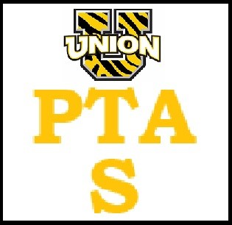

UTS PTA General Meeting January 11, 2023
- · Call to order @ 7:30.
- · Chocolate fundraiser- brochures will be sent to schools in March. Runs for 2 weeks. Last year we made $8000 profit! We will need volunteers once the candy arrives to separate and distribute.
- · Yard sale in May- company that will take everything! No baby gear, pots and pans, and books. Baby gear meaning strollers etc. We would rent spaces to cars for $10, people can sell their items and this company will take all left over items as donations. We can also run a bake sale to raise some extra PTA money. A &E we would need to confirm a day they are available….probably an early Saturday morning. Would need a rain date as well. (May 20TH?) and then rain date the following day?
- · Field Day: spoke to Mr Veit- he is NOT interested in running it but we are welcome to use the equipment. We would need to figure out games etc. June 2nd would be the date with rain date to being the following Thursday. We will have help from the teachers this year. We would get Kona Ice at the ES; would need another idea for MS (if we get enough interest and volunteers for MS). We will put a flyer in the newsletters. We WILL have a February meeting (2/8) solely to discuss Field Day.
- - Pre K will do something separate and NOT on the same day as the rest of the school .
- - We have roughly 200 students. We would need two different colored t shirts. Each class would be divided in half and the classes would compete against each other.
- - Thought is to do it after lunch
- - The PTA and other parents would run the stations. ALL VOLUNTEERS MUST BE PTA MEMBERS
- - Tug of war, potato sack, dizzy race, pool noodle obstacle, etc. Need a volunteer at each station. We have 12 classes.
- - T shirt costs- we will cover. Other ideas were to buy the kids sweatbands in different/team colors. Tie dye shirts? Can ask Mrs Shramko if we supply the goods can she do the dyeing with the kids in school?
- - We could ask parents to donate towards field day items
- · Collecting tabs for Mrs Prentice
- · Gaga Pit- on hold because the cost is high to replace the cost. May consider funding this next year.
- · Discussion about advertising the PTA more, share some of the things we have accomplished over the last school year, etc
- · Habiba discussed TA ideas: no souper bowl. Will get roses for teachers and get kids to make valentines. TA week in May to be discussed further at March PTA meeting.
Meeting adjourned @ 8:45

