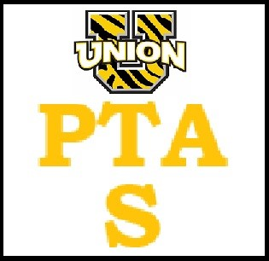
UTS PTA GENERAL MEETING 10/12/22
Call to order by Sarah Daniello @ 7:31

Mini Grant Presentation by Nicole Jones for Pre K thru 5
- Math Stackers: hands on, interactive blocks to assist with math education.
- Why? Critical thinking aspect and hands on... time away from the computers and tablets. Good for small group learning. Good for risk taking and exploration.
- Each teacher could get a set. For now get one set that can be signed out. 96 blocks so we would be getting 6 sets. Each classroom would use 2 sets at a time.
$447 inculdes the curriculum and goes with Big Ideas Math. Comes with free professional development for the teachers.

* mini grant requests are due 11/1. Main priorities include the number of kids that the grant will cover. Mini grant budget for this year is $4000. November meeting will cover mini grants

Trunk or Treat 10/22 (5:30) 6-7:30
All grades included. Emails will go out and flyer to be sent home with each kid. Just under 30 cars signed up. Snack bar will have water, hot cocoa. 300 pumpkins for decoration. Kids will get vouchers for the pumpkin.
Kids not from outside schools pay $2 for pumpkins. Top car will get a $25 gift card to Amazon. Corey is running the pumpkin glow on one end of the pavilion. Pumpkin decorating and games at the other end. Rec is running the snack shack and the games for service hours.
Rain date is Sunday 10/23. Pattenburg Fire is bringing lights to set up. Set up will start around 1 pm. Request is for any Halloween decorations and help set up in advance.
Bring an extension cord for the blow ups.
Will put out a sign up genius for help to set up, take down, etc.

Fun Pasta will begin sales 10/17 and run through 10/28. Flyers to be sent home with kids. Online ordering available.

Meeting adjourned at 8:30 pm

