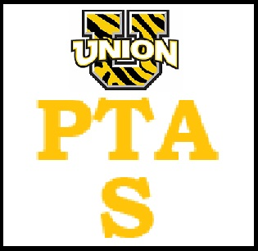

PTA General Meeting 8/17/22

- Call to order 6:05 pm
- PTA Bylaws were amended and available for members to approve before submission to NJPTA
- Financial review- forms/books available for review and signature approval obtained by 3 members. Budget to be finalized and voted on for approval at September meeting
- Fundraising: Paw Print magnets ordered and will be at events ie back to school nights, etc and available for sale for $5. Spirit wear designs ready; items will be available for sale/forms to be sent home to all families in both schools. Chocolate sales were a hit last year and would like to do again this spring. Will also send home flyers reminding families of our fundraising via Amazon Smile, Box Tops.
- Division of PTA into ES and MS/separate entities. As of now plan to separate/earmark funds raised from MS events/fundraising to create their own starting point if we divide next year. To be further discussed at next meeting.
- Trunk or Treat: Sat 10/22 @ Finn Park, raindate 10/23. Corey McCormack present and discussed joint effort with UT Rec, logistics of parking area, pumpkin trail. Discussed a registration fee to those who decorate a pumpkin with proceeds going to PTA. Efforts to help local fire companies fundraise as well. Advertise to UT residents only.
- Possible Turkey Trot at Finn Park on Thanksgiving morning. T shirt vendor- Corey will supply us name. ? Awards/medals
- Teacher Appreciation: Habiba gave a brief overview of events during the year, stressed the need for more assistance/parent volunteers this year. First events for 2022-2023 school year include back to school breakfast/coffee for teachers, lunch/dinner on BTS nights. Sarah added a link in MemberHub for families to make contributions to TA funds.
- Class parents: suggested this get handed back to the teachers rather than run by PTA. Principals emailed and waiting to hear responses.
- Meeting adjourned at 7:25 pm

