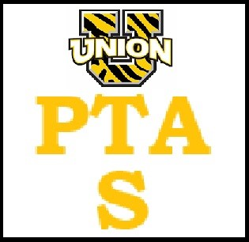
UTS PTA GENERAL MEETING 10/16/23

Attendance:
Sarah Daniello
Alli Ferdinand
Jen Puma
Lisa Schmidt
Flavia DeAreu
Angela Zippi
Trish McNally
Brielle Gomez

Notes:
- Trunk or Treat needs 5 more cares, will be called Monday before if not enough participation, will need to rope off the playground or have parent member monitor the area to keep kids off.
- Need someone to hand out tickets for voting
- Taylor will be at a table with waters and the magnets for sale, put voting bags on some table, bags will have brief description of cars.
Class parents – need list of the parents and emails, not a lot of communication to them on what to do.

Dec 11 -13th – having a Christmas store for the kids to buy gifts for their loved families. Last day may include a family night for last minute shopping. Visit with Santa – possibly cookie decoration. We set aside some money for kids who don’t have any to afford gifts. Will get a list of how many form counselor.

Made a payment towards the back pay of the charity reg. for the state.

Snack bags will be provided for teachers for the conferences. No lunches this year. Taylor M is making them.

